**Saccharides in the PDB**

**Authors**: Shuchismita Dutta, Rutgers University, NJ

**ASBMB Learning Objectives**

(<https://www.asbmb.org/education/core-concept-teaching-strategies/foundational-concepts/structure-function>)

1. Biological macromolecules are large and complex

* Students should be able to **describe the basic units of the macromolecules** and the types of linkages between them *(Introductory)*.

2. Structure is determined by several factors

* Students should be able to **recognize the repeating units in biological macromolecules** and be able to discuss the structural impacts of the covalent and noncovalent interactions involved *(Introductory)*.

### Saccharides:

This document discusses the role of saccharides in biology and why learning about them can be crucial to our understanding of how proteins function. Just like amino acids are the building blocks of proteins, saccharides are also built of smaller building blocks. But the chemistry of these building blocks and how they link together to form polymers is very different.

#### Role in biology:

* Saccharides or sugars are commonly discussed in the context of energy - e.g., glucose is metabolized to produce energy.
* In biology, carbohydrates play key roles in interactions between cells and their surroundings. Glycans, - i.e., single sugars (monosaccharides) and/or their chains (oligosaccharides) either when covalently attached to proteins and lipids or as free-standing molecules can facilitate binding and recognition, leading to infection of host cells by viruses, regulation of cell growth/migration and more (see Figure 0).
* Although glycans play key roles in recognition and regulation, the order in which they link together to form specific structures is not coded by the genome. It is decided by the presence and action of a series of enzymes in the endoplasmic reticulum that act sequentially to add glycans to the proteins and lipids at specific locations.

|  |  |
| --- | --- |
| Structure of human Fc fragment (PDB ID [1fc1](https://www.rcsb.org/structure/1FC1)) | Structure of N9 subtype influenza virus neuraminidase (PDB ID [6nn9](https://www.rcsb.org/structure/6nn9)) |

*Figure 0: A few examples of proteins with linked saccharides that facilitate structural stability and interaction (recognition).*

#### Chemical structure of (mono)saccharides:

* The smallest unit of a saccharide is called a monosaccharide - e.g., glucose, fructose, mannose etc.
* All monosaccharides include multiple carbon atoms forming either an aldehyde or a ketone along with several hydroxyl groups attached to the carbons.
* Based on the number of carbons the monosaccharides are called triose (3 carbons), tetrose (4 carbons), pentose (5 carbons), or hexose (6 carbons), etc.
* The numbering of carbons atoms follows organic chemistry rules - i.e., the aldehyde carbon is referred to as C1, ketone carbon is called C2, and stereogenic carbon furthest away from the carbonyl atom (either C1 or C2) decides the D- and L- classification of the monosaccharide.
  + Aldoses have an aldehyde group (HC=O) at one end, usually the first carbon atom in the molecule, where a (see Figure 1). Here the carbonyl group (C=O) carbon is bound to one carbon and one hydrogen.

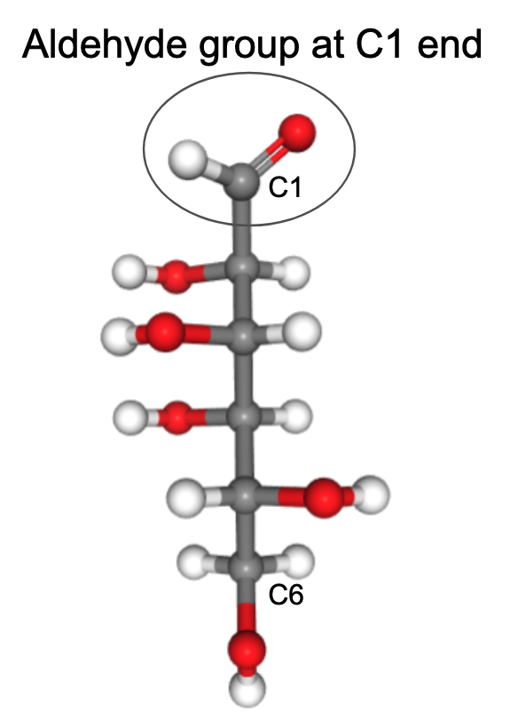

*Figure 1: Aldose sugar glucose (with chemical component ID* [*GLO*](https://www.rcsb.org/ligand/GLO)*)*

* + Ketoses have a ketone group (C=O), usually at the second carbon atom in the molecule (see Figure 2). Here the carbonyl group (C=O) carbon is bound to two other carbons.

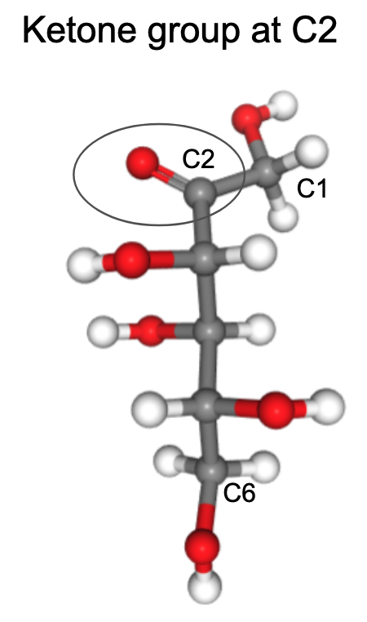

*Figure 2: Ketose sugar Fructose (with chemical components ID* [*FUD*](https://www.rcsb.org/ligand/FUD)*)*

* + Although monosaccharides may be found in their linear form (as shown in figures 1 and 2), they primarily exist in cyclic forms. Cyclization results from the formation of a hemiacetal or hemiketal bond at the C1 or C2 carbonyl atoms in aldoses and ketoses respectively (see Figure 3).
  + Formation of a five-member (furanose) or six-member (pyranose) ring includes one oxygen in the ring. The C1/C2 carbon in the ring is called the anomeric carbon and is the only carbon bound to two Oxygen atoms.

| A. |
| --- |
| B. |

*Figure 3: Cyclization of monosaccharides - A. Hemiacetal formation in aldoses [chemical component IDs* [*GLO*](https://www.rcsb.org/ligand/GLO) *(left) and* [*GLC*](https://www.rcsb.org/ligand/GLC) *(right)]; B. Hemiketal formation in ketoses [chemical component IDs* [*FUD*](https://www.rcsb.org/ligand/FUD) *(left) and* [*FRU*](https://www.rcsb.org/ligand/FRU) *(right)].*

#### Chirality:

Chirality is defined as the property of an object or molecule where it cannot be superimposed on its mirror image by any rotation or translation. Chiral carbons form four tetrahedral bonds with different atoms. Since there are multiple chiral carbons present in monosaccharides, the relative positioning of each of the groups attached to the carbons yield distinct molecules with unique properties and functions.

* **Epimers** - when two monosaccharides differ only in the configuration of one carbon atom (and the rest of the molecule is the same) they are called Epimers. For example D-mannose is a C2 epimer of D-glucose

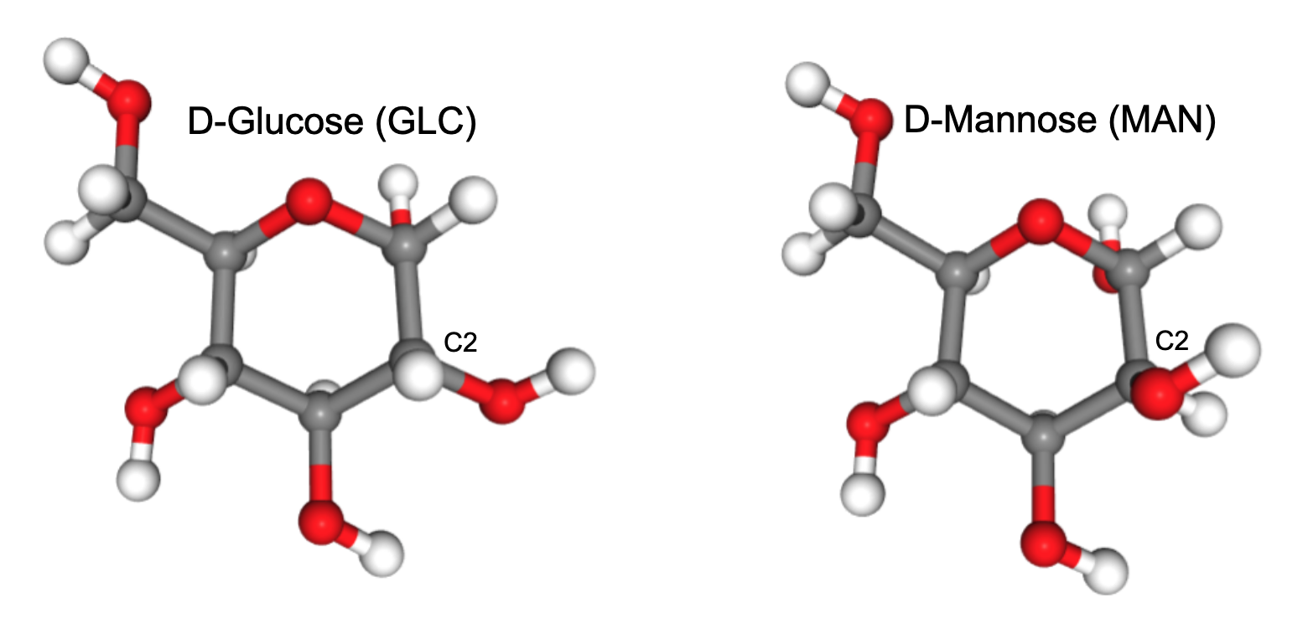

*Figure 4. Epimers - C2 epimers Glucose (*[*GLC*](https://www.rcsb.org/ligand/GLC)*) and Mannose (*[*MAN*](https://www.rcsb.org/ligand/MAN)*). Note that of the atoms linked to the C2 carbon, there is hydrogen coming out of the plane of the page in GLC but oxygen in the case of MAN.*

* **D- and L- saccharides** - the relative position of the hydroxyl stereogenic center furthest from the carbonyl group of the monosaccharide molecule is used to decide the D- and L- configuration. This is often determined using a Fischer projection, as described by the International Union of Pure and Applied Chemistry, International Union of Biochemistry and Molecular Biology, and Joint Commission on Biochemical Nomenclature ([Pure & Appl. Chem., Vol. 68, No. 10, pp. 1919-2008, 1996](https://publications.iupac.org/pac/1996/pdf/6810x1919.pdf)). The D- and L- classification of a monosaccharide may be done as follows:
  + Orient the monosaccharide so that the penultimate (or next to last), steric carbon in the monosaccharide matches its Fischer projection. Pay attention to the last three atoms C4, C5, and C6
  + Position the molecule so that you can imagine it represented as a person standing with open arms - head represented by C4, an oxygen and a hydrogen atom attached to C5, and C6 representing the stick figure’s feet.
  + Orient the molecule so that the head (C4 atom) and feet (C6 atom) are leaning backward, while the C5 atom (to which the “arms” are attached) is pointing up (coming out of the surface of the page/screen)
  + If the O atom attached to this carbon (C5) is on your right it is a D-saccharide and if it is on your left it is an L-saccharide.
  + See the D- and L- classification for Glucose, a pyranose or six-member ring (Figure 5) and Fructose, a furanose or 5 member ring (Figure 6).

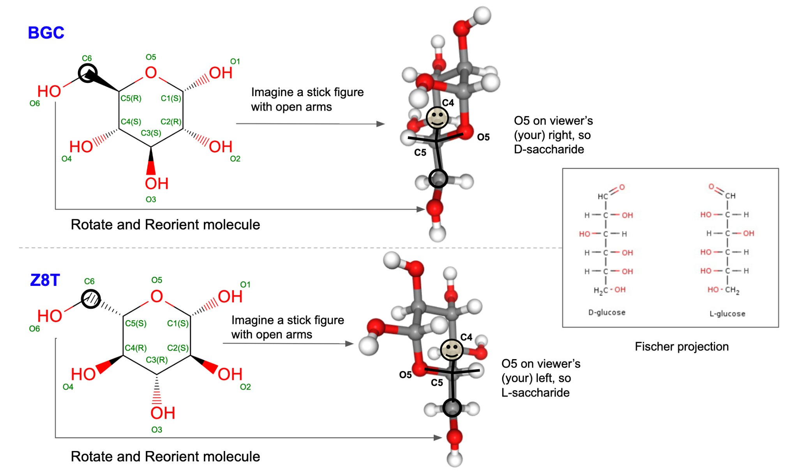

*Figure 5: D-Glucose (GLC) and L-Glucose (Z8T) configurations shown in a 2D drawing, 3D structure with logic for determining D- and L- classification, and Fischer projections of the molecules.*

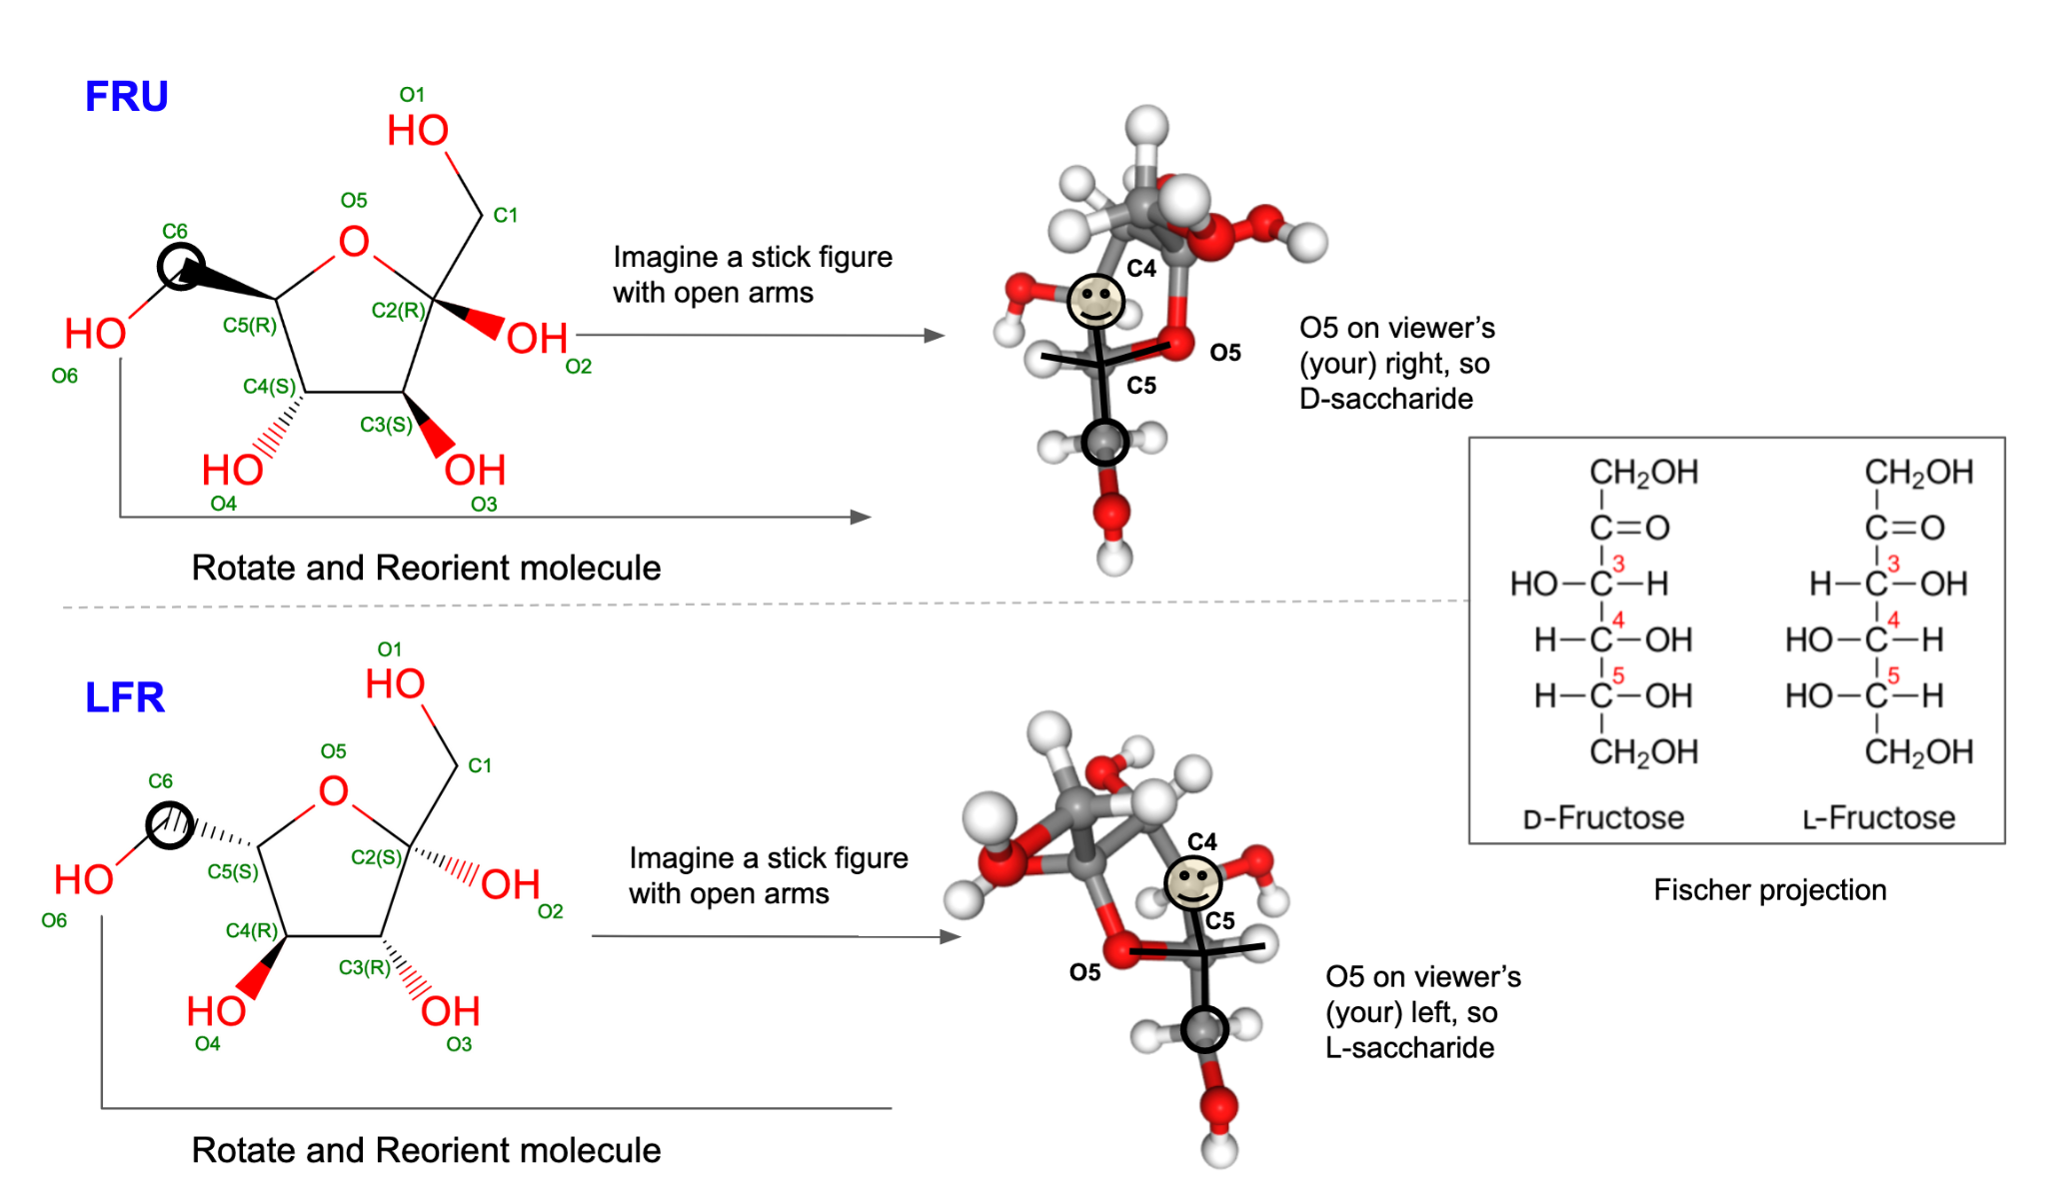

*Figure 6: D-Fructose (FRU) and L-Fructose (LFR) configurations shown in a 2D drawing, 3D structure with logic for determining D- and L- classification, and Fischer projections of the molecules.*

* **𝝰 and 𝝱 - sugars** - when the sugar molecule forms a ring, a new asymmetric center is generated at the anomeric carbon. This carbon has two oxygen atoms attached to it - one in the ring and a hydroxyl group outside the ring. Comparing the configurations of the anomeric carbon and that of a specific anomeric reference atom (i.e., the highest-numbered chiral carbon atom next to the anomeric center that is involved in the heterocyclic ring) determines the classification of 𝝰 and 𝝱 saccharides. When the configurations at these carbons are the same, the monosaccharide is defined as the α anomer, and when they are different, the monosaccharide is defined as the β anomer. To determine if a monosaccharide is an α or a β anomer use the following steps:
  + Orient the saccharide molecule so that it matches the Fischer projection of the saccharide around the anomeric C (i.e., C1 in glucose) and highest number chiral C connected to the ring (C5 in glucose). Note the configurations - if they are the same it is an 𝝰 sugar/saccharide (Figure 7), and if it is different it is a 𝝱 sugar/saccharide (Figure 8)

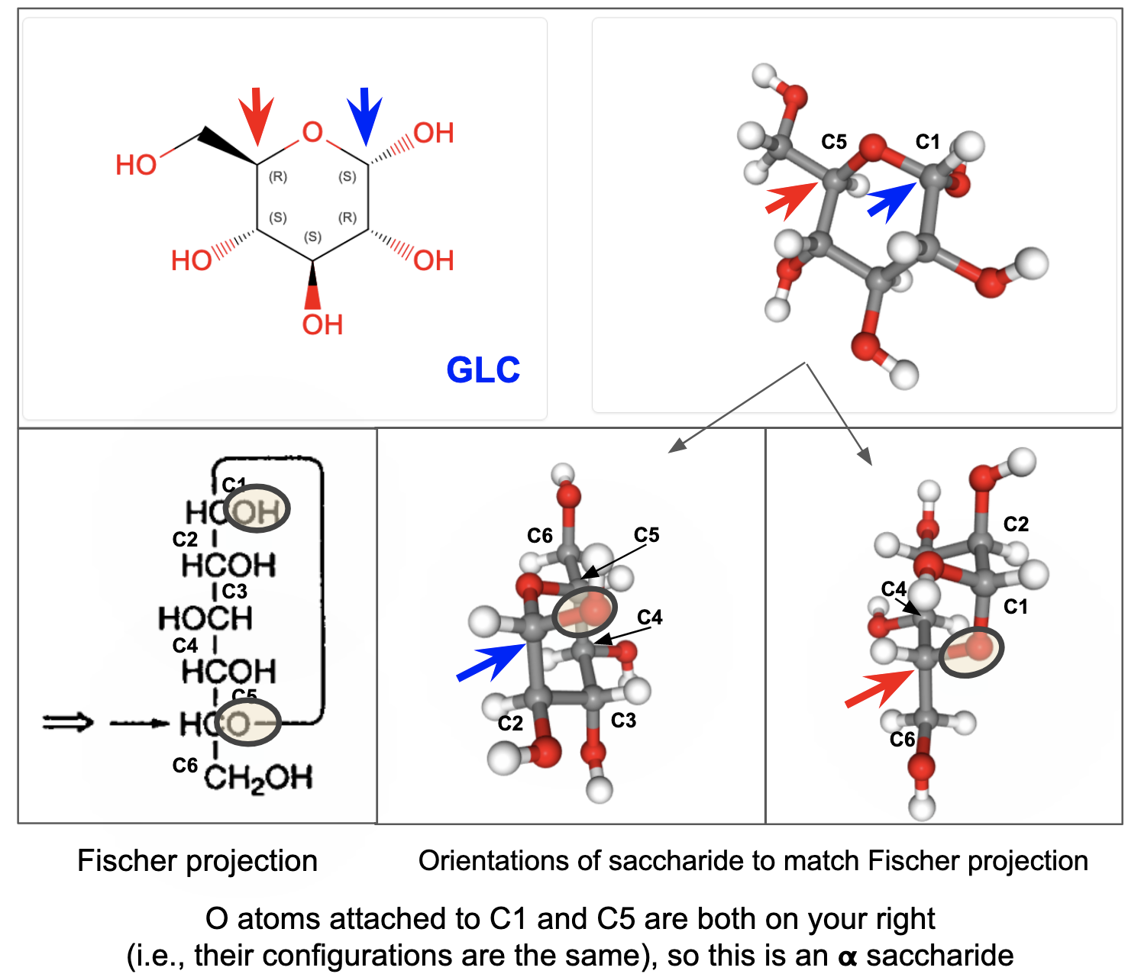

*Figure 7: Alpha (****𝝰****) configurations of glucose GLC showing the rationale for this classification. Configurations at C1 (blue arrow) and C5 (red arrow) are the same.*

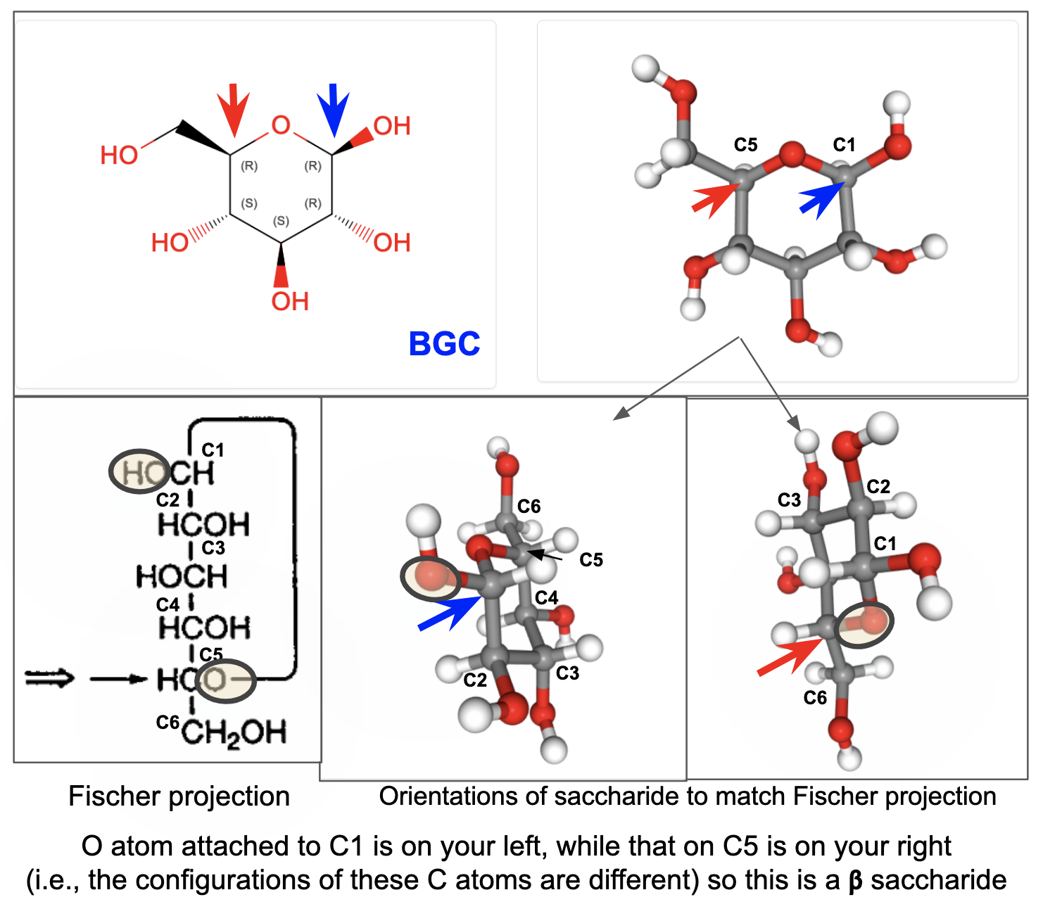

*Figure 8: Beta (****𝝱****) configurations of glucose BGC showing the rationale for this classification. Configurations at C1 (blue arrow) and C5 (red arrow) are different.*

Note:

* While the D- and L- classification of sugars focuses on the configuration of the stereogenic carbon furthest away from the carbonyl atom in the sugar, relationship of the configuration at this carbon compared to the anomeric carbon determined the 𝝰 and 𝝱 classification.
* Knowledge of configurations at the anomeric carbon is important in determining the types of linkages that are formed between monosaccharides - e.g., 𝝰 1→4 linkages vs 𝝱 1→ 4 linkages.
* Most common saccharide units in nature are D-sugars, but are able to form both 𝝰 and 𝝱 linkages forming very different structures, recognized by different proteins and enzymes.

Did you know that the definitions, chemical formulae, and representative coordinates for all saccharides are available in the Chemical Component Dictionary (maintained by the [worldwide PDB](https://www.wwpdb.org/) (wwPDB)? You can search for these components or ligands using the [Ligand Expo](http://ligand-expo.rcsb.org/index.html) tool or directly from the [RCSB PDB](https://www.rcsb.org/) website.

### Explore:

* Explore a few common monosaccharide components in the PDB:

| [Glucose](https://www.rcsb.org/search?request=%7B%22query%22%3A%7B%22type%22%3A%22group%22%2C%22nodes%22%3A%5B%7B%22type%22%3A%22group%22%2C%22nodes%22%3A%5B%7B%22type%22%3A%22group%22%2C%22nodes%22%3A%5B%7B%22type%22%3A%22terminal%22%2C%22service%22%3A%22text_chem%22%2C%22parameters%22%3A%7B%22attribute%22%3A%22rcsb_chem_comp_container_identifiers.comp_id%22%2C%22operator%22%3A%22in%22%2C%22value%22%3A%5B%22glo%22%2C%22glc%22%2C%22bgc%22%2C%22z8t%22%5D%2C%22negation%22%3Afalse%7D%7D%5D%2C%22logical_operator%22%3A%22and%22%7D%5D%2C%22logical_operator%22%3A%22and%22%2C%22label%22%3A%22text_chem%22%7D%5D%2C%22logical_operator%22%3A%22and%22%7D%2C%22return_type%22%3A%22mol_definition%22%2C%22request_options%22%3A%7B%22paginate%22%3A%7B%22start%22%3A0%2C%22rows%22%3A25%7D%2C%22results_content_type%22%3A%5B%22experimental%22%5D%2C%22sort%22%3A%5B%7B%22sort_by%22%3A%22score%22%2C%22direction%22%3A%22desc%22%7D%5D%2C%22scoring_strategy%22%3A%22combined%22%7D%2C%22request_info%22%3A%7B%22query_id%22%3A%2236e7a76c1da776962deca166b9ab9a2b%22%7D%7D)  [Mannose](https://www.rcsb.org/search?request=%7B%22query%22%3A%7B%22type%22%3A%22group%22%2C%22nodes%22%3A%5B%7B%22type%22%3A%22group%22%2C%22logical_operator%22%3A%22and%22%2C%22nodes%22%3A%5B%7B%22type%22%3A%22group%22%2C%22nodes%22%3A%5B%7B%22type%22%3A%22terminal%22%2C%22service%22%3A%22text_chem%22%2C%22parameters%22%3A%7B%22attribute%22%3A%22rcsb_chem_comp_container_identifiers.comp_id%22%2C%22operator%22%3A%22in%22%2C%22negation%22%3Afalse%2C%22value%22%3A%5B%22man%22%2C%22bma%22%5D%7D%7D%5D%2C%22logical_operator%22%3A%22and%22%7D%5D%2C%22label%22%3A%22text_chem%22%7D%5D%2C%22logical_operator%22%3A%22and%22%7D%2C%22return_type%22%3A%22mol_definition%22%2C%22request_options%22%3A%7B%22paginate%22%3A%7B%22start%22%3A0%2C%22rows%22%3A25%7D%2C%22results_content_type%22%3A%5B%22experimental%22%5D%2C%22sort%22%3A%5B%7B%22sort_by%22%3A%22score%22%2C%22direction%22%3A%22desc%22%7D%5D%2C%22scoring_strategy%22%3A%22combined%22%7D%2C%22request_info%22%3A%7B%22query_id%22%3A%22c3814befd1025fca2d6a75ba23f46b19%22%7D%7D) | [Fructose](https://www.rcsb.org/search?request=%7B%22query%22%3A%7B%22type%22%3A%22group%22%2C%22nodes%22%3A%5B%7B%22type%22%3A%22group%22%2C%22logical_operator%22%3A%22and%22%2C%22nodes%22%3A%5B%7B%22type%22%3A%22group%22%2C%22nodes%22%3A%5B%7B%22type%22%3A%22terminal%22%2C%22service%22%3A%22text_chem%22%2C%22parameters%22%3A%7B%22attribute%22%3A%22rcsb_chem_comp_container_identifiers.comp_id%22%2C%22operator%22%3A%22in%22%2C%22negation%22%3Afalse%2C%22value%22%3A%5B%22fud%22%2C%22fru%22%2C%22bdf%22%2C%22lfr%22%5D%7D%7D%5D%2C%22logical_operator%22%3A%22and%22%7D%5D%2C%22label%22%3A%22text_chem%22%7D%5D%2C%22logical_operator%22%3A%22and%22%7D%2C%22return_type%22%3A%22mol_definition%22%2C%22request_options%22%3A%7B%22paginate%22%3A%7B%22start%22%3A0%2C%22rows%22%3A25%7D%2C%22results_content_type%22%3A%5B%22experimental%22%5D%2C%22sort%22%3A%5B%7B%22sort_by%22%3A%22score%22%2C%22direction%22%3A%22desc%22%7D%5D%2C%22scoring_strategy%22%3A%22combined%22%7D%2C%22request_info%22%3A%7B%22query_id%22%3A%22a75383f3e993c7507bfe8549abc79f05%22%7D%7D)  [Galactose](https://www.rcsb.org/search?request=%7B%22query%22%3A%7B%22type%22%3A%22group%22%2C%22nodes%22%3A%5B%7B%22type%22%3A%22group%22%2C%22nodes%22%3A%5B%7B%22type%22%3A%22group%22%2C%22nodes%22%3A%5B%7B%22type%22%3A%22terminal%22%2C%22service%22%3A%22text_chem%22%2C%22parameters%22%3A%7B%22attribute%22%3A%22rcsb_chem_comp_container_identifiers.comp_id%22%2C%22operator%22%3A%22in%22%2C%22value%22%3A%5B%22gxl%22%2C%22gla%22%2C%22giv%22%2C%22gal%22%5D%2C%22negation%22%3Afalse%7D%7D%5D%2C%22logical_operator%22%3A%22and%22%7D%5D%2C%22logical_operator%22%3A%22and%22%2C%22label%22%3A%22text_chem%22%7D%5D%2C%22logical_operator%22%3A%22and%22%7D%2C%22return_type%22%3A%22mol_definition%22%2C%22request_options%22%3A%7B%22paginate%22%3A%7B%22start%22%3A0%2C%22rows%22%3A25%7D%2C%22results_content_type%22%3A%5B%22experimental%22%5D%2C%22sort%22%3A%5B%7B%22sort_by%22%3A%22score%22%2C%22direction%22%3A%22desc%22%7D%5D%2C%22scoring_strategy%22%3A%22combined%22%7D%2C%22request_info%22%3A%7B%22query_id%22%3A%22503f39f2c1bc296c658dcb956f6a3442%22%7D%7D) | [Xylose](https://www.rcsb.org/search?request=%7B%22query%22%3A%7B%22type%22%3A%22group%22%2C%22nodes%22%3A%5B%7B%22type%22%3A%22group%22%2C%22logical_operator%22%3A%22and%22%2C%22nodes%22%3A%5B%7B%22type%22%3A%22group%22%2C%22nodes%22%3A%5B%7B%22type%22%3A%22terminal%22%2C%22service%22%3A%22text_chem%22%2C%22parameters%22%3A%7B%22attribute%22%3A%22rcsb_chem_comp_container_identifiers.comp_id%22%2C%22operator%22%3A%22in%22%2C%22negation%22%3Afalse%2C%22value%22%3A%5B%22xls%22%2C%22lxc%22%2C%22xyp%22%2C%22xyz%22%2C%22xys%22%5D%7D%7D%5D%2C%22logical_operator%22%3A%22and%22%7D%5D%2C%22label%22%3A%22text_chem%22%7D%5D%2C%22logical_operator%22%3A%22and%22%7D%2C%22return_type%22%3A%22mol_definition%22%2C%22request_options%22%3A%7B%22paginate%22%3A%7B%22start%22%3A0%2C%22rows%22%3A25%7D%2C%22results_content_type%22%3A%5B%22experimental%22%5D%2C%22sort%22%3A%5B%7B%22sort_by%22%3A%22score%22%2C%22direction%22%3A%22desc%22%7D%5D%2C%22scoring_strategy%22%3A%22combined%22%7D%2C%22request_info%22%3A%7B%22query_id%22%3A%221ee0c8b740218837a402ceec7d799ca0%22%7D%7D)  [Fucose](https://www.rcsb.org/search?request=%7B%22query%22%3A%7B%22type%22%3A%22group%22%2C%22nodes%22%3A%5B%7B%22type%22%3A%22group%22%2C%22logical_operator%22%3A%22and%22%2C%22nodes%22%3A%5B%7B%22type%22%3A%22group%22%2C%22nodes%22%3A%5B%7B%22type%22%3A%22terminal%22%2C%22service%22%3A%22text_chem%22%2C%22parameters%22%3A%7B%22attribute%22%3A%22rcsb_chem_comp_container_identifiers.comp_id%22%2C%22operator%22%3A%22in%22%2C%22negation%22%3Afalse%2C%22value%22%3A%5B%22fuc%22%2C%22fcb%22%2C%22ful%22%2C%22fca%22%2C%22gye%22%5D%7D%7D%5D%2C%22logical_operator%22%3A%22and%22%7D%5D%2C%22label%22%3A%22text_chem%22%7D%5D%2C%22logical_operator%22%3A%22and%22%7D%2C%22return_type%22%3A%22mol_definition%22%2C%22request_options%22%3A%7B%22paginate%22%3A%7B%22start%22%3A0%2C%22rows%22%3A25%7D%2C%22results_content_type%22%3A%5B%22experimental%22%5D%2C%22sort%22%3A%5B%7B%22sort_by%22%3A%22score%22%2C%22direction%22%3A%22desc%22%7D%5D%2C%22scoring_strategy%22%3A%22combined%22%7D%2C%22request_info%22%3A%7B%22query_id%22%3A%222f1311a236015678a873e9f3da021dac%22%7D%7D) | [Glucuronic acid](https://www.rcsb.org/search?request=%7B%22query%22%3A%7B%22type%22%3A%22group%22%2C%22nodes%22%3A%5B%7B%22type%22%3A%22group%22%2C%22logical_operator%22%3A%22and%22%2C%22nodes%22%3A%5B%7B%22type%22%3A%22group%22%2C%22nodes%22%3A%5B%7B%22type%22%3A%22terminal%22%2C%22service%22%3A%22text_chem%22%2C%22parameters%22%3A%7B%22attribute%22%3A%22rcsb_chem_comp_container_identifiers.comp_id%22%2C%22operator%22%3A%22in%22%2C%22negation%22%3Afalse%2C%22value%22%3A%5B%22gcu%22%2C%22bdp%22%2C%22rel%22%5D%7D%7D%5D%2C%22logical_operator%22%3A%22and%22%7D%5D%2C%22label%22%3A%22text_chem%22%7D%5D%2C%22logical_operator%22%3A%22and%22%7D%2C%22return_type%22%3A%22mol_definition%22%2C%22request_options%22%3A%7B%22paginate%22%3A%7B%22start%22%3A0%2C%22rows%22%3A25%7D%2C%22results_content_type%22%3A%5B%22experimental%22%5D%2C%22sort%22%3A%5B%7B%22sort_by%22%3A%22score%22%2C%22direction%22%3A%22desc%22%7D%5D%2C%22scoring_strategy%22%3A%22combined%22%7D%2C%22request_info%22%3A%7B%22query_id%22%3A%223e6aa020b5f8b276e19a696d09179d82%22%7D%7D)  [N-acetyl-neuraminic acid](https://www.rcsb.org/search?request=%7B%22query%22%3A%7B%22type%22%3A%22group%22%2C%22nodes%22%3A%5B%7B%22type%22%3A%22group%22%2C%22logical_operator%22%3A%22and%22%2C%22nodes%22%3A%5B%7B%22type%22%3A%22group%22%2C%22nodes%22%3A%5B%7B%22type%22%3A%22terminal%22%2C%22service%22%3A%22text_chem%22%2C%22parameters%22%3A%7B%22attribute%22%3A%22rcsb_chem_comp_container_identifiers.comp_id%22%2C%22operator%22%3A%22in%22%2C%22negation%22%3Afalse%2C%22value%22%3A%5B%22SIA%22%2C%22SLB%22%5D%7D%7D%5D%2C%22logical_operator%22%3A%22and%22%7D%5D%2C%22label%22%3A%22text_chem%22%7D%5D%2C%22logical_operator%22%3A%22and%22%7D%2C%22return_type%22%3A%22mol_definition%22%2C%22request_options%22%3A%7B%22paginate%22%3A%7B%22start%22%3A0%2C%22rows%22%3A25%7D%2C%22results_content_type%22%3A%5B%22experimental%22%5D%2C%22sort%22%3A%5B%7B%22sort_by%22%3A%22score%22%2C%22direction%22%3A%22desc%22%7D%5D%2C%22scoring_strategy%22%3A%22combined%22%7D%2C%22request_info%22%3A%7B%22query_id%22%3A%22ab0b0347bf794bcffd046708764ed73d%22%7D%7D) |
| --- | --- | --- | --- |

Note that there are a few different configurations (or structures) possible for each of the sugars.

* Besides these common saccharides, PDB structures have many modified saccharides with a variety of other groups attached to them (e.g., methyl, acetyl, hydroxyl, amino groups). While many of these are present in nature, there are several that are designed. Explore all [L-saccharides](https://www.rcsb.org/search?request=%7B%22query%22%3A%7B%22type%22%3A%22group%22%2C%22logical_operator%22%3A%22and%22%2C%22nodes%22%3A%5B%7B%22type%22%3A%22group%22%2C%22logical_operator%22%3A%22and%22%2C%22nodes%22%3A%5B%7B%22type%22%3A%22group%22%2C%22nodes%22%3A%5B%7B%22type%22%3A%22terminal%22%2C%22service%22%3A%22text_chem%22%2C%22parameters%22%3A%7B%22attribute%22%3A%22chem_comp.type%22%2C%22operator%22%3A%22exact_match%22%2C%22negation%22%3Afalse%2C%22value%22%3A%22L-saccharide%22%7D%7D%5D%2C%22logical_operator%22%3A%22and%22%7D%5D%2C%22label%22%3A%22text_chem%22%7D%5D%7D%2C%22return_type%22%3A%22mol_definition%22%2C%22request_options%22%3A%7B%22paginate%22%3A%7B%22start%22%3A0%2C%22rows%22%3A25%7D%2C%22results_content_type%22%3A%5B%22experimental%22%5D%2C%22sort%22%3A%5B%7B%22sort_by%22%3A%22score%22%2C%22direction%22%3A%22desc%22%7D%5D%2C%22scoring_strategy%22%3A%22combined%22%7D%2C%22request_info%22%3A%7B%22query_id%22%3A%226455aab5d43bed009fdab8d3e6991706%22%7D%7D) and [D-saccharides](https://www.rcsb.org/search?request=%7B%22query%22%3A%7B%22type%22%3A%22group%22%2C%22logical_operator%22%3A%22and%22%2C%22nodes%22%3A%5B%7B%22type%22%3A%22group%22%2C%22logical_operator%22%3A%22and%22%2C%22nodes%22%3A%5B%7B%22type%22%3A%22group%22%2C%22nodes%22%3A%5B%7B%22type%22%3A%22terminal%22%2C%22service%22%3A%22text_chem%22%2C%22parameters%22%3A%7B%22attribute%22%3A%22chem_comp.type%22%2C%22operator%22%3A%22exact_match%22%2C%22negation%22%3Afalse%2C%22value%22%3A%22D-saccharide%22%7D%7D%5D%2C%22logical_operator%22%3A%22and%22%7D%5D%2C%22label%22%3A%22text_chem%22%7D%5D%7D%2C%22return_type%22%3A%22mol_definition%22%2C%22request_options%22%3A%7B%22paginate%22%3A%7B%22start%22%3A0%2C%22rows%22%3A25%7D%2C%22results_content_type%22%3A%5B%22experimental%22%5D%2C%22sort%22%3A%5B%7B%22sort_by%22%3A%22score%22%2C%22direction%22%3A%22desc%22%7D%5D%2C%22scoring_strategy%22%3A%22combined%22%7D%2C%22request_info%22%3A%7B%22query_id%22%3A%22178048c95633de824edd8042523c4206%22%7D%7D) in PDB’s Chemical Component Dictionary to learn more. Make a gallery of these saccharides by clicking on the  icon at the top of the list of the saccharides listed on the page.

### Examine:

To learn more about each monosaccharide you can examine its ligand summary page.

For example for [GLC](https://www.rcsb.org/ligand/GLC), you can

* Examine the 2D and 3D structures of the molecule

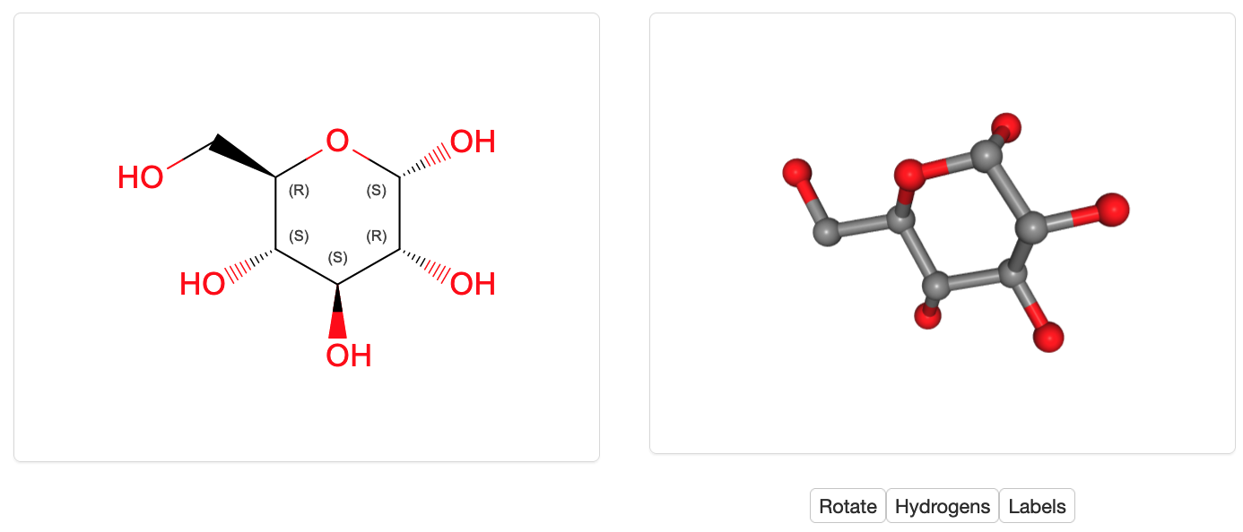

* Access the complete chemical name, formula, and other chemical identifiers

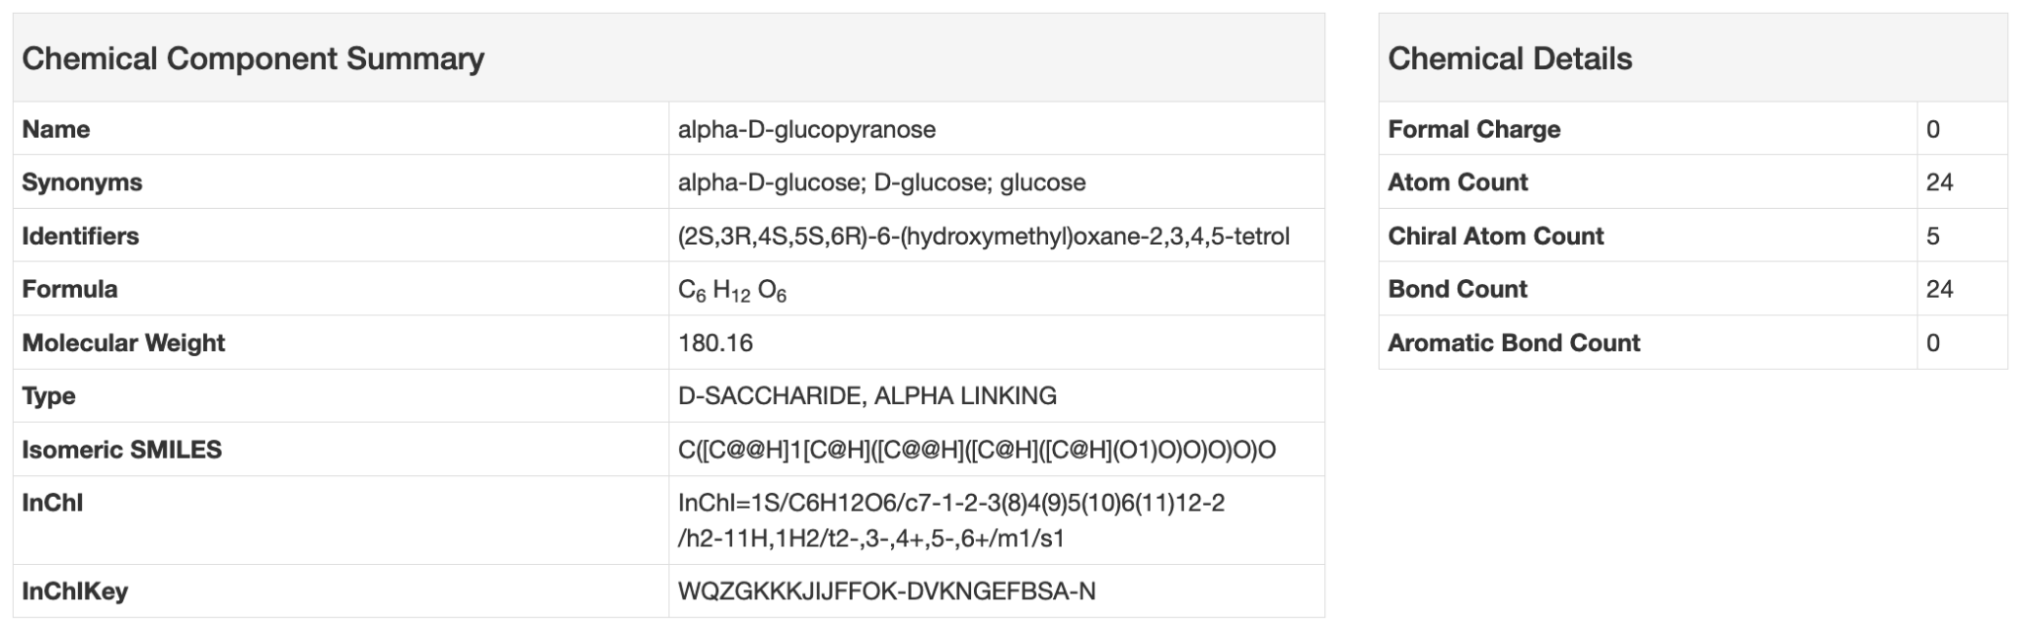

* Download files, identify PDB entries where the molecule is present as part of a polymer, covalently bound, or interacting through non-covalent interactions.

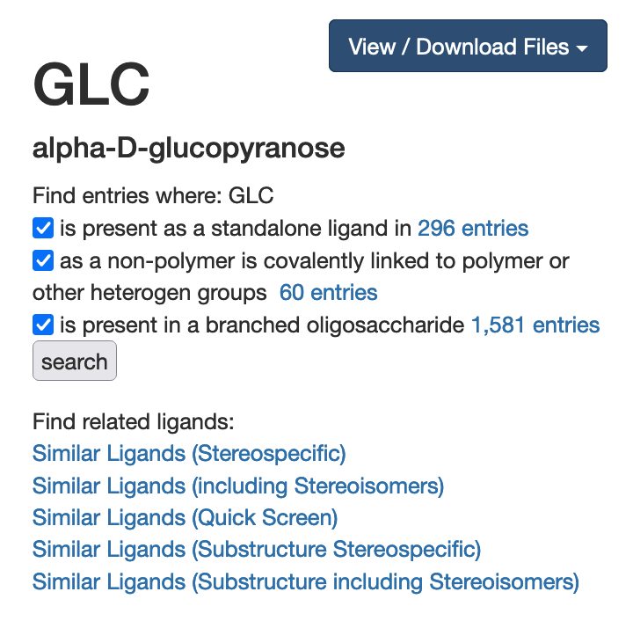

* Find other ligands in the dictionary with the same or similar chemical properties.



In the results returned, look to see if you can recognize aldoses, ketoses, D- and L- sugars, epimers, anomers (𝝰 and 𝝱 sugars) all with the same chemical formula!

* Where available, access additional information about the molecule from other bioinformatics resources.

